SUMMER 2024

Q.1. (A) Attempt any ONE

a) Enlist any four characteristics of cloud computing:
Cloud computing has several defining characteristics. Four key ones are:
- On-Demand Self-Service:
  - Users can automatically provision computing resources like servers and storage without human interaction.
  - 📌 Example: Google Cloud lets users create virtual machines at any time.
- Broad Network Access:
  - Cloud services are accessible over the network (internet/intranet) using standard devices such as laptops, tablets, and smartphones.
  - 📌 Example: Google Docs can be accessed from any internet-enabled device.
- Resource Pooling:
  - Resources (like CPU, storage) are pooled together and assigned dynamically to different customers.
  - 📌 Example: A single physical server in AWS might run VMs for multiple clients.
- Rapid Elasticity:
  - Resources can be rapidly and elastically scaled up or down as per demand.
  - 📌 Example: An e-commerce site getting more server resources during a festive sale.

b) Define any two cloud deployment models:

i) Public Cloud:
- Definition: A deployment model where services are provided over the internet and shared among multiple organizations.
- Provider Examples: Amazon Web Services (AWS), Microsoft Azure.
- Benefits: Cost-effective, scalable, no maintenance.
- 📌 Example: A startup hosting its website on AWS S3.

ii) Private Cloud:
- Definition: Cloud infrastructure operated solely for one organization, either on-premises or by a third-party.
- Benefits: High control, security, and customization.
- 📌 Example: A bank using private cloud for customer transaction processing.

iii) Hybrid Cloud:
- Definition: A combination of public and private clouds, allowing data and applications to be shared between them.
- Benefits: Flexibility, cost optimization.
- 📌 Example: An enterprise using a private cloud for sensitive data and public cloud for analytics.

Q.1. (B) Attempt any TWO

a) Describe the architecture of cloud computing:
Cloud computi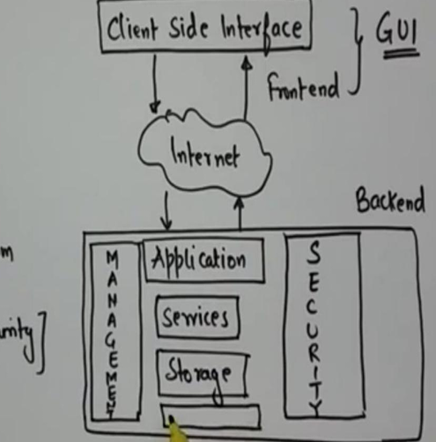ng architecture has two main components:
- Front-end:
  - Interface for users to interact with the cloud (e.g., web browsers, client applications).
  - 📌 Example: Google Drive interface.
- Back-end:
  - Includes servers, storage, virtual machines, and data centers managed by cloud providers.
Additional elements:
- Cloud Service Models: IaaS, PaaS, SaaS.
- Cloud Deployment Models: Public, Private, Hybrid.
- Virtualization Layer: Uses hypervisors like VMware, Hyper-V.

b) Write steps to use cloud-based Integrated Development Environment (IDE) to develop education-related application:
- Sign up/Login to a Cloud IDE (e.g., Replit, GitHub Codespaces).
- Create a New Project – Select a programming language (e.g., Python, JavaScript).
- Write Application Code – Example: An online quiz platform or learning portal.
- Use Built-in Tools – Debugger, version control (Git), and package manager.
- Test Application – Run tests within the IDE using built-in emulator or web preview.
- Deploy or Export – Export code or directly deploy to a hosting service like Vercel or Heroku.
- Collaborate – Share code with teachers/students for real-time editing.

c) Describe any two service models of cloud computing:

i) IaaS (Infrastructure as a Service):
- Offers virtualized computing infrastructure over the internet.
- Includes virtual machines, storage, and networking.
- 📌 Example: Amazon EC2, Google Compute Engine.

ii) PaaS (Platform as a Service):
- Provides platform-level tools like OS, runtime, and database for application development.
- Developers don’t manage infrastructure.
- 📌 Example: Google App Engine, Microsoft Azure App Services.

iii) SaaS (Software as a Service):
- Software hosted in the cloud and accessed via browser.
- 📌 Example: Gmail, Dropbox, Microsoft 365.

Up next: Q.2 in detail! Ready?

Q.2 (A) Attempt any TWO

a) Enlist any two advantages of KVM (Kernel-based Virtual Machine):
KVM is a virtualization solution for Linux on x86 hardware.
- Open Source and Cost-Effective:
  - KVM is part of the Linux kernel and comes free with most Linux distributions.
  - 📌 Example: Red Hat and Ubuntu users can use KVM without paying for additional licenses.
- Strong Performance and Scalability:
  - KVM provides near-native performance by using hardware virtualization (Intel VT or AMD-V).
  - Easily scalable to run multiple virtual machines efficiently.
📝 Bonus Info: KVM converts the Linux kernel into a bare-metal hypervisor (Type 1 behavior), although it technically operates like a Type 2 hypervisor.

b) Describe VM migration:
VM Migration is the process of moving a virtual machine from one physical host to another.

Types of VM Migration:
- Cold Migration:
  - VM is powered off before migration.
  - Simple, but causes downtime.
  - 📌 Use case: Scheduled maintenance.
- Live Migration:
  - VM continues running while being moved.
  - Zero or near-zero downtime.
  - 📌 Use case: Load balancing without interrupting user sessions.

Steps in VM Migration:
- Identify overloaded or underused physical machine (PM).
- Select suitable VM(s) to migrate.
- Choose destination PM with enough resources.
- Transfer VM files and state to new PM.
- Resume VM execution (if live).

Example:
- In VMware vSphere, “vMotion” is used for live migration between ESXi hosts.

c) List any four characteristics of a virtualized environment:
- Isolation:
  - Each virtual machine (VM) operates independently and is isolated from others.
  - Prevents one VM from affecting others.
- Sharing:
  - Multiple VMs share the same physical hardware, leading to better utilization.
  - 📌 Example: 10 VMs sharing one physical server.
- Portability:
  - VMs can be moved from one physical machine to another easily.
  - Aids in disaster recovery and load balancing.
- Aggregation:
  - Opposite of sharing: multiple physical systems can appear as one virtual host to users.
  - Useful in distributed systems or big data setups.

Q.2 (B) Attempt any ONE

a) Write generic steps to build a virtual machine using VMware on Windows 10:
- Download and Install VMware Workstation:
  - Use the official website to install VMware Workstation or Workstation Player.
- Launch VMware:
  - Open VMware and click “Create a New Virtual Machine.”
- Choose Configuration Type:
  - Select “Typical” for beginners or “Custom” for advanced users.
- Select Installer Disk/Image:
  - Choose an ISO file or physical disk to install an OS (e.g., Ubuntu ISO).
- Name the VM and Set Location:
  - Provide a name and select where the VM files should be saved.
- Specify Disk Capacity:
  - Set the virtual hard disk size and choose whether it should be split into multiple files or stored as one.
- Customize Hardware (Optional):
  - Allocate CPU cores, RAM, network adapter type, etc.
- Finish Setup:
  - Click Finish. VM will now appear in the dashboard.
- Start the VM:
  - Power on and install the operating system from the selected ISO.

b) Explain levels of virtualization:
There are three main levels of virtualization:
- Hardware-Level Virtualization:
  - Uses a hypervisor to abstract physical hardware.
  - Hypervisors: VMware ESXi, KVM, Hyper-V.
  - 📌 Example: Running multiple VMs on a server.
- Operating System-Level Virtualization:
  - Also called container-based virtualization.
  - No hypervisor; isolates user spaces within the OS.
  - 📌 Example: Docker, LXC.
- Application-Level Virtualization:
  - Virtualizes applications instead of OS or hardware.
  - Apps run in isolated containers without full OS.
  - 📌 Example: Microsoft App-V, Wine.

Q.3 (A) Attempt any TWO

a) Define Virtual Provisioning:
Virtual Provisioning, also known as Thin Provisioning, is a storage strategy used in SAN (Storage Area Network) environments. It allows administrators to allocate storage on-demand, rather than upfront.

Key Concepts:
- It gives the illusion of more storage than physically available.
- Physical disk space is only used when data is actually written.
- Helps in avoiding over-provisioning and saves storage cost.

📌 Example:
If a user is given 1TB of virtual space but only uses 200GB, the physical storage used is only 200GB, not the full 1TB.

✅ Advantages:
- Reduces idle storage cost.
- Enhances storage efficiency.
- Simplifies administration.

b) State any two benefits of Virtual Data Centre (VDC):
A Virtual Data Centre (VDC) is a collection of cloud resources that simulate a physical data center.

1. Cost Efficiency:
- Reduces capital expenditure (CAPEX) as there's no need for physical infrastructure.
- Pay-as-you-use model.
- 📌 Example: Startups using VDC avoid buying expensive servers.

2. High Flexibility and Scalability:
- You can easily scale resources like CPU, memory, and storage up/down.
- Faster deployment of new applications or services.

c) Enlist different virtualization techniques:
- Full Virtualization:
  - Complete simulation of hardware.
  - Guest OS doesn’t need modifications.
  - 📌 Example: VMware, VirtualBox.
- Para-Virtualization:
  - Guest OS is modified to work with the hypervisor.
  - More efficient than full virtualization.
  - 📌 Example: Xen Hypervisor.
- OS-Level Virtualization:
  - Uses a single OS kernel with isolated containers.
  - 📌 Example: Docker, LXC.
- Hardware-Assisted Virtualization:
  - Uses CPU features like Intel VT-x and AMD-V to support virtualization.
  - Works with modern hypervisors.

Q.3 (B) Attempt any THREE

a) Compare Block-Level and File-Level Storage:
Feature | Block-Level Storage | File-Level Storage
Storage Type | Data stored in fixed-size blocks | Data stored as complete files
Access Method | Accessed by operating systems directly | Accessed via file system (e.g., NTFS, ext4)
Flexibility | Highly flexible, suitable for databases | Simple and user-friendly
Use Case | Databases, VMs, transactional systems | File servers, media storage, documents
Example | SAN (Storage Area Network) | NAS (Network Attached Storage)

b) Write and describe the key components required to set up a Virtual Data Centre (VDC):
- Compute Resources (Hosts and Clusters):
  - Physical servers with virtualization software (e.g., ESXi).
  - Hosts grouped into clusters for load balancing.
- Storage Resources (Datastores):
  - Logical representations of physical storage like SAN, NAS.
  - Used to store VM files and application data.
- Network Resources:
  - vSwitches, port groups, and virtual NICs.
  - Connect VMs to internal or external networks.
- Virtual Machines (VMs):
  - Simulated servers that run OS and applications.
  - Can be scaled or migrated easily.

c) Explain benefits of VSAN (Virtual Storage Area Network) in detail:
VSAN is a software-defined storage system that pools together local storage from multiple servers and presents it as shared storage.

✅ Benefits:
- Lower Cost:
  - No need for expensive physical SAN hardware.
  - Uses existing server storage.
- High Availability:
  - Automatically replicates data across nodes.
  - Eliminates single points of failure.
- Flexibility and Scalability:
  - Easily expand storage by adding nodes.
  - Configurable according to workload.
- Simplified Management:
  - Centralized dashboard to manage storage.
  - Integrates with hypervisors like VMware.

d) Draw and explain the architecture of VDC:
Here’s a text-based breakdown (I'll generate a diagram if needed too):
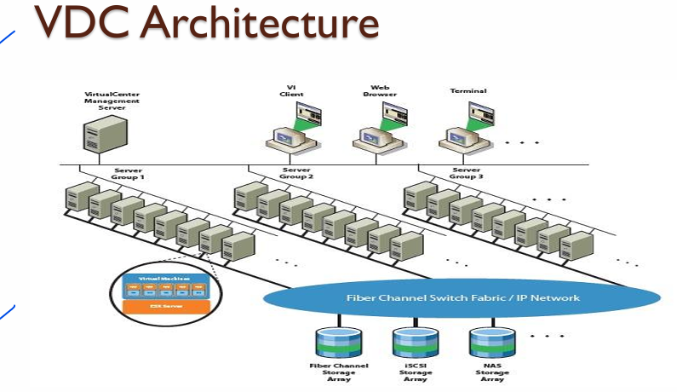

Components:
- Hosts & Clusters: Physical servers running hypervisors.
- VMs: Simulate computers with OS/apps.
- Datastores: Logical containers for VM data (backed by SAN/NAS).
- Networks: Virtualized networking (vSwitches, etc.) to connect VMs.

Q.4. (A) Attempt any TWO

a) Write any four benefits of Federated Cloud:
Federated Cloud is a collaboration of multiple cloud providers to share resources.

✅ Benefits:
- Energy Efficiency:
  - Reduces overall energy consumption by balancing loads across providers.
- Scalability:
  - Instantly scales by borrowing resources from partner clouds.
- Reliability:
  - If one cloud fails, services continue from another, improving fault tolerance.
- Cost Efficiency:
  - Organizations can choose the most cost-effective provider for specific tasks.
📌 Example: During high traffic, a university’s private cloud may borrow compute power from a public cloud like AWS.

b) Define Service Level Agreement (SLA):
A Service Level Agreement (SLA) is a formal contract between a cloud service provider and the customer, defining:
- What services will be provided.
- Performance standards.
- Availability (e.g., uptime).
- Security responsibilities.
- Penalties in case of violations.
📌 Example: A cloud provider guarantees 99.9% uptime in an SLA. If not met, the client may get a refund or credit.

c) List the items in the SLA checklist:
An SLA checklist typically includes:
- Service Scope and Description
- Performance Metrics (e.g., uptime, latency)
- Availability Guarantees
- Support & Response Time
- Disaster Recovery and Backup
- Security Protocols
- Escalation Procedures
- Penalties for SLA Violation
- Termination Conditions
- Data Ownership and Portability

Q.4. (B) Attempt any THREE

a) Draw architecture of Federated Cloud:

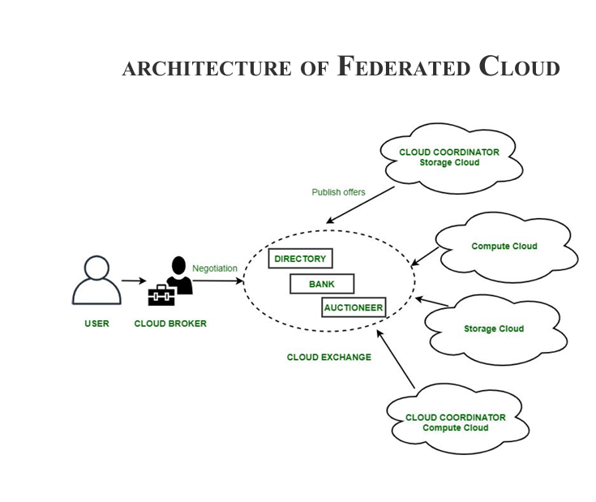

b) Analyze the cloud service lifecycle to provide cloud services in your institute:
The Cloud Service Lifecycle has 4 main phases:

x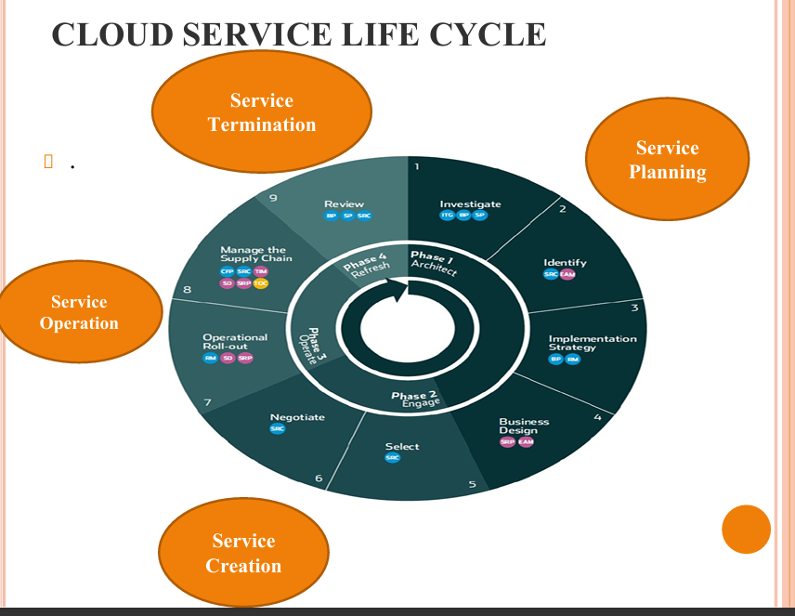

1. Architect (Plan):
- Assess the institution’s needs (e.g., online learning platforms).
- Identify services to outsource (storage, LMS, etc.).

2. Engage (Procure):
- Select a suitable provider (e.g., AWS Educate, Google Cloud for Education).
- Negotiate and sign SLA.

3. Operate (Manage):
- Set up cloud services.
- Regular monitoring, maintenance, and user support.
- Provide access to students/faculty.

4. Refresh (Review):
- Review system performance.
- Upgrade services, scale up or change provider as needed.

c) Explain AB-INITIO Resource Assignment:
AB-INITIO refers to initial resource assignment when a cloud consumer makes a request for the first time.
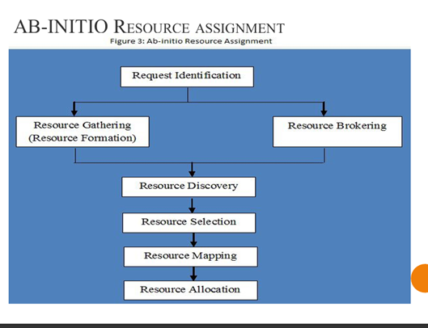

🧠 Steps:
- Request Identification:
  - Identify what resources are needed (e.g., storage, compute).
- Resource Gathering:
  - Cloud provider gathers available resources.
- Resource Brokering:
  - Negotiates cost and SLA with consumer.
- Resource Discovery:
  - Logical grouping of resources (e.g., CPU, RAM).
- Resource Selection:
  - Chooses optimal resources for the task.
- Resource Mapping:
  - Maps virtual resources to physical servers.
- Resource Allocation:
  - Assigns resources and enables usage.
📌 Example: A college student accesses a virtual lab VM for the first time — these steps are followed in the background.

d) Explain cloud service life cycle phases:

Phase 1: Architect
- Define goals and impact.
- Design new service and strategy.
- 📌 Example: Decide to deploy ERP on the cloud.

Phase 2: Engage
- Select best provider.
- Negotiate SLA and sign contract.

Phase 3: Operate
- Deploy the service.
- Transition staff roles, ensure communication.
- Manage supply chain, monitor usage.

Phase 4: Refresh
- Regular reviews and evaluations.
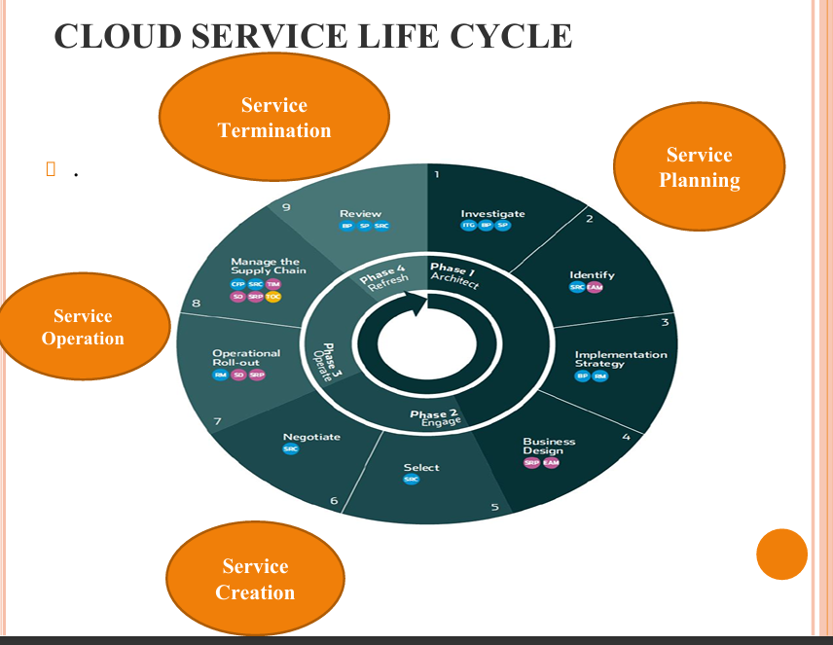

Q.5. (A) Attempt any ONE

a) State the advantages of cloud computing security:
Security in cloud computing ensures data protection, service continuity, and compliance. Key benefits include:

✅ 1. Data Protection & Backup:
- Data is replicated across multiple locations, ensuring high availability.
- Automatic backups reduce the risk of data loss.

✅ 2. Access Control & Authentication:
- Advanced access controls like Multi-Factor Authentication (MFA).
- Fine-grained Identity and Access Management (IAM) policies.

✅ 3. Cost Efficiency:
- No need for expensive on-prem security tools — it's bundled with cloud services.
- Pay-as-you-go models for security tools.

✅ 4. Scalability of Security:
- As your cloud infrastructure scales, the security protocols also scale.
- Dynamic firewalls, intrusion detection, and encryption are managed automatically.

✅ 5. Compliance & Auditing:
- Cloud providers help meet standards like ISO, HIPAA, GDPR, etc.
- Regular auditing tools are provided by vendors (e.g., AWS CloudTrail).

b) Explain the following terms regarding risk:

i) Data Loss:
- Definition: Data is deleted, corrupted, or becomes unreadable.
- Causes:
  - Accidental deletion.
  - Hardware failure.
  - Cyberattacks like ransomware.
  - Natural disasters.
- Cloud Impact: Even in the cloud, if proper redundancy or backups aren’t configured, data may be unrecoverable.
- 📌 Example: If a customer doesn't enable versioning in AWS S3, a deleted file may be permanently lost.

ii) Vendor Lock-in:
- Definition: Difficulty in switching from one cloud provider to another due to:
  - Proprietary tools/APIs.
  - Data format incompatibility.
  - High data transfer costs.
- Problem: Limits flexibility, increases costs, and poses security risks during migration.
- 📌 Example: Moving from AWS Lambda to Google Cloud Functions may require rewriting large parts of application logic.

Q.5. (B) Attempt any TWO

a) Explain benefits of Security as a Service (SECaaS):
Security as a Service (SECaaS) is a cloud-based delivery of security services.

✅ Benefits:
- Reduced Costs:
  - No need to purchase and maintain on-premise hardware/software.
- Always Updated:
  - Continuous updates protect against the latest threats without manual intervention.
- Centralized Management:
  - Monitor security from a single dashboard for all devices and users.
- Rapid Deployment:
  - Services like antivirus, firewalls, and IAM can be quickly deployed.
- Scalability:
  - Easily scale security services as users and devices increase.
📌 Examples of SECaaS: McAfee SECaaS, Zscaler, Symantec Cloud Security.

b) Describe any four general issues in security in cloud computing:

1. Data Breaches:
- Unauthorized access to sensitive data.
- Often caused by poor access controls or misconfigured storage.

2. Insecure APIs:
- APIs are exposed publicly to manage cloud services.
- If not properly secured, attackers can exploit them.

3. Denial of Service (DoS) Attacks:
- Flood cloud systems with traffic to exhaust resources and cause downtime.

4. Account Hijacking:
- Stolen credentials allow attackers to access and control cloud resources.
- Can lead to theft, deletion, or corruption of data.

c) Analyze three steps of implementation of cloud-based Identity and Access Management (IAM):

Step 1: Identity Provisioning
- Assign identities to users, devices, and services.
- Integrate with directory services like Azure AD or AWS IAM.

Step 2: Access Control Policies
- Define who can access what using:
  - Role-Based Access Control (RBAC)
  - Attribute-Based Access Control (ABAC)
- Implement fine-grained permissions and segregation of duties.

Step 3: Monitoring and Audit
- Track access logs and usage patterns.
- Tools: AWS CloudTrail, Azure Monitor.
- Helps in detecting suspicious activity and ensuring compliance.

You're acing this! 💯 Let me know when you’re ready to tackle the final one — Q.6.
4o

Q.6 (A) Attempt any ONE

a) Define Ubiquitous Computing:
Ubiquitous Computing (also called pervasive computing) is a concept where computers are embedded into everyday objects and environments, making technology seamlessly integrate with the real world.

✅ Key Features:
- Devices work in the background, without needing constant human interaction.
- Provides context-aware services (e.g., reacting to time, location, presence).
- Connects multiple smart devices using IoT and cloud computing.

📌 Examples:
- Smart thermostats that adjust based on your location.
- Wearable health devices that send data to your doctor via the cloud.

b) Enlist the benefits of Smart Buildings:
Smart buildings use IoT, cloud, and automation to improve performance and sustainability.

✅ Benefits:
- Energy Efficiency:
  - Smart lighting and HVAC reduce power consumption based on real-time needs.
- Improved Security:
  - Smart surveillance, access control systems, and alarms.
- Remote Monitoring and Control:
  - Control systems (like lights, AC) remotely via smartphones or dashboards.
- Cost Saving:
  - Reduces energy bills and maintenance costs through predictive monitoring.
- Enhanced Comfort:
  - Personalized climate and lighting settings for occupants.

Q.6 (B) Attempt any TWO

a) Explain RFID Tags and Device Components:

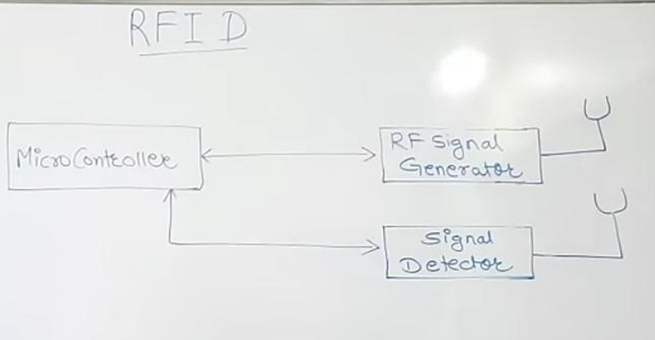
RFID (Radio Frequency Identification) is a wireless technology used to identify and track objects using radio waves.

✅ Components:
- RFID Tag (Transponder):
  - Contains a microchip with data and an antenna.
  - Types: Passive (no battery), Active (has battery).
- RFID Reader (Transceiver):
  - Sends radio waves to detect RFID tags and read the data.
- Antenna:
  - Transmits signals between the tag and reader.
- Middleware/Software:
  - Collects and processes data from the reader and integrates with systems.

📌 Example:
- A library uses RFID tags in books to automatically detect check-in and check-out.

b) Describe the IoT technologies used for Home Automation and relate it to Cloud Computing:

✅ IoT Technologies for Home Automation:
- Wi-Fi / Bluetooth / Zigbee:
  - Connects smart devices (lights, plugs, thermostats) to a local network or hub.
- Smart Sensors:
  - Detect motion, light, temperature, etc.
- Smart Hubs:
  - Central unit to control all devices (e.g., Google Nest, Amazon Echo).
- Mobile Apps:
  - Control devices remotely.

📡 Relation with Cloud Computing:
- Data Storage:
  - Sensor data is sent to the cloud for processing and storage.
- Remote Access:
  - Cloud enables users to control home devices from anywhere via the internet.
- Automation:
  - Cloud-based services like IFTTT automate routines (e.g., turn on lights at sunset).
- Voice Assistants:
  - Amazon Alexa and Google Assistant use cloud APIs to control smart devices.

c) Describe the steps to configure the server using Amazon EC2 to secure it:
To secure an Amazon EC2 server, follow these steps:

✅ Step 1: Launch EC2 Instance
- Choose an OS (e.g., Ubuntu).
- Select instance type (e.g., t2.micro for free tier).
- Create and download a key pair for SSH access.

✅ Step 2: Configure Security Groups
- Define firewall rules.
  - Allow only specific IPs for SSH (port 22).
  - Open HTTP (80) or HTTPS (443) if it's a web server.

✅ Step 3: Login to Server
- Use SSH with your .pem key:
bash
Copy code
ssh -i "your-key.pem" ubuntu@<ec2-public-ip>

✅ Step 4: Update Server & Install Security Tools
bash
Copy code
sudo apt update && sudo apt upgrade
sudo apt install ufw fail2ban

✅ Step 5: Configure Firewall
bash
Copy code
sudo ufw allow ssh
sudo ufw allow http
sudo ufw enable

✅ Step 6: Set Up Fail2Ban
- Protects from brute-force attacks.
- Monitors log files and blocks IPs after failed login attempts.

✅ Step 7: Disable Root Login & Password Authentication (Optional)
- Edit /etc/ssh/sshd_config:
nginx
Copy code
PermitRootLogin no
PasswordAuthentication no
- Then restart SSH service:
bash
Copy code
sudo systemctl restart ssh

🎉 That's a complete, detailed answer to Q.6!
WINTER 2024

Q.1. (A) Attempt any ONE

a) State need of cloud computing:
Cloud computing is essential in today’s digital world due to the following needs:

✅ 1. Scalability:
- Dynamically scale resources (compute/storage) based on workload demands.

✅ 2. Cost Efficiency:
- Pay-as-you-go pricing avoids upfront hardware investment.

✅ 3. Accessibility:
- Access services from anywhere with internet—ideal for remote teams and students.

✅ 4. Business Continuity & Disaster Recovery:
- Built-in redundancy and backup ensure service continuity.

✅ 5. Focus on Core Business:
- Reduces the need for managing infrastructure, allowing teams to focus on application logic or services.

b) Define SaaS (Software as a Service):
SaaS is a cloud service model where software applications are delivered over the internet as a fully managed service.

✅ Characteristics:
- No need to install or maintain software locally.
- Accessible through web browsers.
- Subscription-based pricing.

📌 Examples:
- Gmail, Dropbox, Microsoft Office 365.

Q.1. (B) Attempt any TWO

a) Describe any four features of cloud service models:
- Self-Service Provisioning:
  - Users can deploy services (e.g., VMs, apps) without human intervention.
- Multi-Tenancy:
  - Resources are shared among multiple users securely.
- Elasticity:
  - Resources automatically scale based on demand.
- Pay-as-You-Go:
  - Users are billed only for what they use (e.g., compute hours, storage GBs).

b) Explain cloud deployment models:
- Public Cloud:
  - Services are provided over the internet by third-party vendors (e.g., AWS, Azure).
- Private Cloud:
  - Cloud infrastructure is used by a single organization for higher security and control.
- Hybrid Cloud:
  - Combination of public and private clouds for optimized flexibility and cost.
- Community Cloud:
  - Shared among organizations with common requirements (e.g., government).

c) Compare IaaS, PaaS, SaaS:
Feature | IaaS | PaaS | SaaS
Users | SysAdmins, DevOps | Developers | End Users
Access | VMs, Storage, Networking | Platforms & Frameworks | Full Applications
Examples | AWS EC2, Azure VM | Google App Engine, Heroku | Gmail, Google Docs
Control | Full control over OS | Control over app only | No control over infra/app

Q.2. (A) Attempt any TWO

a) Define VM Consolidation:
VM Consolidation is the technique of combining multiple virtual machines onto fewer physical machines to optimize resource utilization and reduce energy usage.

📌 Strategies:
- VM Placement: Placing VMs optimally.
- VM Migration: Moving VMs from underutilized or overloaded servers.

b) Define Hardware Virtualization:
Hardware virtualization is the creation of virtual versions of hardware components using a hypervisor.

✅ Benefits:
- Run multiple OS on one physical machine.
- Better resource utilization.

📌 Example:
Using VMware ESXi to run Ubuntu, Windows, and CentOS VMs on a single server.

c) List any two disadvantages of virtualization:
- Performance Overhead:
  - Virtualization introduces some latency compared to native hardware.
- Security Vulnerabilities:
  - If the hypervisor is compromised, all VMs are at risk.

Q.2. (B) Attempt any ONE

a) Describe levels of virtualization:
- Hardware-Level Virtualization:
  - Uses hypervisors to simulate hardware.
  - Example: VMware ESXi.
- OS-Level Virtualization:
  - Uses containers to isolate apps.
  - Example: Docker, LXC.
- Application-Level Virtualization:
  - Applications run in a self-contained environment.
  - Example: Wine, Citrix.

b) Describe Reference Model of Virtualization:

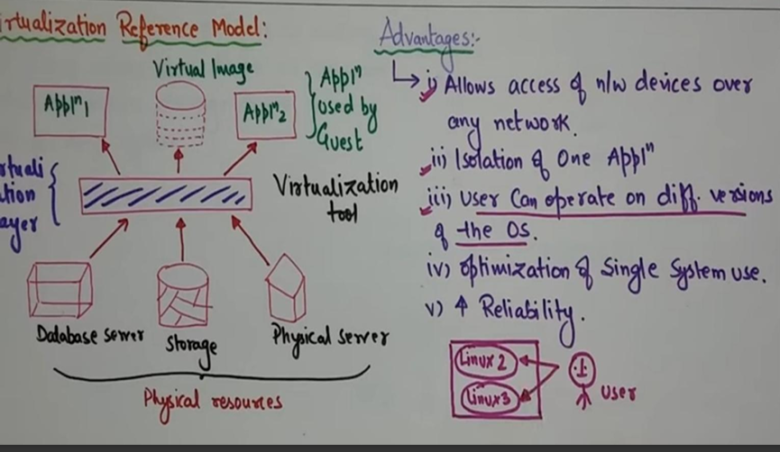
Reference Model Components:
- Host Machine:
  - The physical server that runs everything.
- Virtualization Layer (Hypervisor):
  - Software like VMware, Hyper-V that separates VMs from hardware.
- Guest OS:
  - OS running on a VM, independent of host OS.
📌 The model shows how virtualization abstracts hardware and provides isolated environments to each VM.

Q.3. (A) Attempt any TWO

a) Write any two benefits of Virtual Data Center (VDC):
- Cost-Efficiency:
  - No need for physical servers or storage devices.
- Scalability:
  - Instantly increase or decrease resources based on demand.

b) Define File-Level Storage Virtualization in Cloud:
File-Level Storage Virtualization is where data is stored and accessed as complete files in a directory hierarchy, abstracted from physical storage.

📌 Examples:
- Google Drive, Dropbox.
- Cloud applications access files via paths without knowing actual storage backend.

c) State need of Google File System (GFS):
GFS was developed to address:
- Handling Large Files:
  - Supports files in GBs to petabytes range.
- Fault Tolerance:
  - Built-in replication ensures availability despite hardware failures.
- High Throughput:
  - Optimized for large sequential reads and writes, suitable for big data processing.

Q.3. (B) Attempt any THREE

a) Draw and explain VDC architecture:
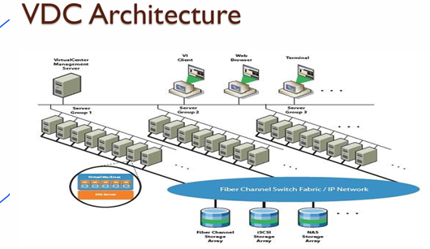Each component represents a virtualized version of traditional data center elements.

b) Explain architecture of Google File System (GFS):

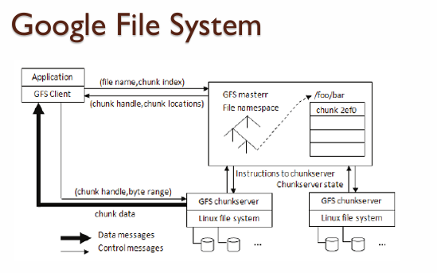
GFS Components:
- Master Server:
  - Manages metadata and file system namespace.
- Chunk Servers:
  - Store fixed-size data chunks (64MB each).
- Clients:
  - Request data from chunk servers using metadata from the master.
📌 Each chunk is replicated on 3+ chunk servers for redundancy.

c) Describe advantages of GFS and HDFS:
Feature | GFS | HDFS
Scalability | Scales to petabytes | Designed for large datasets
Fault Tolerance | Replication of chunks | Data replicated across datanodes
High Throughput | Optimized for big sequential ops | Write-once, read-many model
Commodity Hardware | Yes | Yes

d) Describe benefits of Virtual Storage Area Network (VSAN):
- Lower Cost:
  - Uses local disks, no need for separate SAN hardware.
- High Availability:
  - Replicates data across servers to avoid single point of failure.
- Flexible and Scalable:
  - Add more nodes to increase capacity.
- Simplified Management:
  - Managed from a single dashboard, integrated with virtualization platforms.

Q.4 (A) Attempt any TWO

a) List components of Federated Cloud:
A Federated Cloud integrates multiple cloud providers for seamless resource sharing. Key components include:
- Cloud Providers:
  - Offer services (compute, storage, etc.) to the federation.
- Cloud Broker:
  - Acts as an intermediary to manage services across providers.
  - Handles SLA negotiation, monitoring, and service selection.
- Cloud Exchange:
  - Platform for resource sharing, pricing, and matchmaking.
- Cloud Coordinator:
  - Manages local cloud infrastructure and ensures SLA compliance.

b) Write any two functions of Cloud Portal:
- User Interface for Service Management:
  - Enables users to provision and manage cloud services (e.g., VMs, storage).
- Billing and Usage Monitoring:
  - Displays real-time usage and cost tracking for the services used.

c) State taxonomy of resource management:
Resource management in cloud computing is categorized as:
- Resource Allocation:
  - Assigning resources (CPU, memory, etc.) to users or services.
- Resource Provisioning:
  - Pre-configuring resources for future use.
- Resource Scheduling:
  - Deciding the order and time for resource access.
- Resource Monitoring:
  - Tracking resource usage and performance in real-time.
- Resource Optimization:
  - Improving efficiency by consolidating or reallocating resources.

Q.4 (B) Attempt any THREE

a) Describe Periodic Resource Optimization:
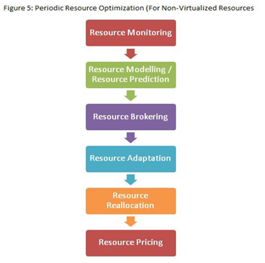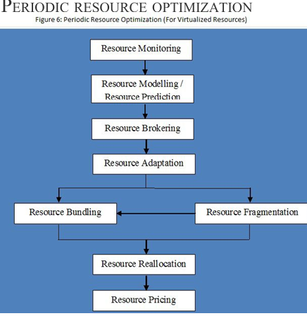It is a scheduled strategy to:
- Analyze current resource utilization.
- Identify underutilized or overutilized resources.
- Reallocate or consolidate VMs to improve performance and reduce costs.
📌 Example: Migrating idle VMs to fewer servers every night to save power.

b) Analyze the cloud service lifecycle required to provide cloud services in your institute:

Phases:
- Architect:
  - Analyze institute needs (e.g., online learning, storage).
  - Choose appropriate cloud architecture.
- Engage:
  - Choose provider (AWS Educate, Azure for Students).
  - Define SLAs, roles, and access levels.
- Operate:
  - Deploy services like LMS, virtual labs, storage.
  - Monitor services and train staff.
- Refresh:
  - Periodically review performance and costs.
  - Upgrade or switch services as needed.

c) Describe Ab-initio Resource Assignment:


Refers to the initial allocation of cloud resources when a request is made.

Steps:
- Request analysis
- Resource selection (based on availability)
- SLA negotiation
- Allocation and mapping
- Service initialization
📌 Example: When a student requests a virtual lab session, the system assigns a VM and network automatically.

d) Describe SLA Life Cycle:



1. Creation:
- Define service levels, performance metrics, penalties.

2. Implementation:
- Embed SLA terms in system monitoring and alerts.

3. Monitoring:
- Track uptime, latency, response time.

4. Violation Handling:
- If metrics are not met, apply penalties or remedies.

5. Review/Termination:
- Periodically review SLA and renew, update, or terminate.

Q.5 (A) Attempt any ONE

a) State need of Content Level Security:
Content-level security protects data within applications, not just at the file or disk level.

Why it's needed:
- Prevents data leakage from shared environments.
- Ensures end-to-end encryption (even inside apps).
- Enforces granular access control on content.
📌 Example: Encrypting individual emails or chat messages inside a platform like Gmail.

b) Define Data Masking:
Data Masking is a process of replacing sensitive data with fictitious but realistic data.

Purpose:
- Used for testing, training, or analytics without exposing real data.
📌 Example: Replacing real customer credit card numbers with fake ones in a demo database.

Q.5 (B) Attempt any TWO

a) Describe Digital Identity and Access Management (IAM):
IAM controls who can access what in a system.

Key Components:
- User Authentication: Verifies identity (e.g., passwords, biometrics).
- Authorization: Defines user permissions.
- Audit & Logging: Records activity for monitoring.
📌 Example: AWS IAM lets you grant developers read-only access to S3.

b) Describe challenges of Cloud Security:
- Data Breaches
- Misconfigured Access Controls
- Compliance Issues (GDPR, HIPAA)
- Multi-Tenancy Risks
- Denial of Service (DoS) Attacks

c) Describe technologies used for data security:
- Encryption (AES, RSA):
  - Encrypts data at rest and in transit.
- Tokenization:
  - Replaces sensitive data with a token.
- Firewalls and Intrusion Detection:
  - Monitors and blocks suspicious traffic.
- Access Controls (RBAC, MFA):
  - Only authorized users can access data.

Q.6 (A) Attempt any ONE

a) Define Windows Azure Cloud Platform:
Microsoft Azure is a public cloud platform offering:
- Compute: VMs, Functions
- Storage: Blob, Tables, Queues
- Databases: SQL, Cosmos DB
- AI, DevOps, IoT services
- Integration with Microsoft tools (Office, AD)

b) What is Google App Engine?
Google App Engine is a Platform as a Service (PaaS) for building and hosting web apps.

Features:
- Auto-scaling
- Supports multiple languages (Python, Java, Go, etc.)
- Integrated with Google Cloud services
- Handles deployment, monitoring, and load balancing

Q.6 (B) Attempt any TWO

a) Compare AWS and Azure features:
Feature | AWS | Microsoft Azure
Compute | EC2 | Virtual Machines
Storage | S3, EBS | Blob, Disk Storage
Free Tier | 12-month + always free | 30-day credit + always free
AI Tools | SageMaker | Azure ML Studio
Integration | Works well with Linux tools | Strong MS Office & AD integration
Hybrid Support | Outposts | Azure Stack

b) Describe Amazon EC2 and its basic features:
Amazon EC2 (Elastic Compute Cloud) is an IaaS service that provides resizable compute capacity.

✅ Features:
- Virtual servers (instances)
- Choice of OS (Linux, Windows)
- Instance types (general, compute-optimized, etc.)
- Secure with key pairs and security groups
- Auto-scaling and Elastic Load Balancer (ELB)

c) Describe steps to configure the server using Microsoft Azure to secure it:

Step 1: Create VM
- Select OS, VM size, and region
- Add user credentials (SSH or password)

Step 2: Configure NSG (Network Security Group)
- Open required ports (SSH, HTTP)
- Restrict IPs to known sources

Step 3: Enable Security Center
- Get threat alerts, recommendations, and compliance status

Step 4: Patch Management
- Enable automatic OS updates

Step 5: Enable Backup and Recovery
- Set up Azure Backup for VMs

Step 6: Install Endpoint Protection
- Use Microsoft Defender or third-party antivirus

SUMMER 2023
Q.1 (A) Attempt any ONE:
(a) State Private Cloud: A private cloud is a cloud computing environment that is dedicated solely to a single organization. It can be hosted on-premises or by a third-party provider. The private cloud offers enhanced security, control, and customization options compared to public clouds, making it suitable for organizations with sensitive data and compliance requirements.
Advantages:
- Enhanced security and privacy
- Greater control over resources
- Customization options
- Improved performance
Disadvantages:
- High cost of infrastructure and maintenance
- Requires skilled IT staff
Example: VMware vSphere, OpenStack
(b) Define PaaS Service Model: Platform as a Service (PaaS) is a cloud computing model that provides a platform and environment to develop, test, and deploy applications without the complexity of managing the underlying infrastructure. PaaS offers tools, libraries, and frameworks for developers to build applications.
Example: Google App Engine, AWS Elastic Beanstalk

Q.1 (B) Attempt any TWO:
(a) Differentiate between Cloud Service Models:
Feature | IaaS | PaaS | SaaS
Control | Full control over infrastructure | Limited control over platform | No control, only access to software
Management | Managed by user | Managed by provider | Fully managed by provider
Cost | Pay-per-use model | Subscription-based | Subscription or freemium model
Example | AWS EC2, Google Compute Engine | AWS Elastic Beanstalk, Google App Engine | Google Docs, Dropbox
(b) Characteristics of Cloud Computing:
- On-Demand Self-Service
- Broad Network Access
- Resource Pooling
- Rapid Elasticity
- Measured Service
(c) Architecture of Cloud Computing:

- Frontend Layer: User interface and client devices.
- Application Layer: Cloud services and applications.
- Platform Layer: Middleware and runtime environments.
- Infrastructure Layer: Virtual machines, storage, and networking.
- Security Layer: Access control and encryption.

Q.2 (A) Attempt any TWO:
(a) Advantages of Virtualization:
- Improved resource utilization
- Cost efficiency
- Enhanced security
- Disaster recovery and backup
(b) Define KVM: Kernel-based Virtual Machine (KVM) is an open-source virtualization technology built into the Linux kernel. It allows the creation of virtual machines with their own isolated environments, running different operating systems on a single physical host.
(c) Advantages and Disadvantages of Consolidation:
Advantages:
- Reduced hardware costs
- Enhanced resource utilization
Disadvantages:
- Performance bottlenecks
- Security vulnerabilities

Q.2 (B) Attempt any ONE:
(a) VM Migration: VM migration is the process of moving a virtual machine from one physical server to another without downtime. It is used for load balancing, hardware maintenance, and disaster recovery.
Types:
- Cold Migration (VM is powered off)
- Live Migration (VM is running)
(b) Desktop and Application Virtualization:
- Desktop Virtualization: Provides remote access to a desktop environment hosted on a centralized server. (Example: Citrix XenDesktop)
- Application Virtualization: Allows running applications in isolated environments without installing them on the host machine. (Example: VMware ThinApp)

Q.3 (A) Attempt any TWO:
(a) Define Virtual Storage Area Network (VSAN): A VSAN is a software-defined storage solution that pools storage resources from multiple servers into a single virtual storage pool. It enhances scalability, flexibility, and cost-efficiency.
(b) Virtual Provisioning: Virtual provisioning (Thin Provisioning) dynamically allocates storage resources as needed rather than pre-allocating physical storage space. It reduces costs and improves storage efficiency.
(c) Need of Google File System (GFS): GFS is designed to handle large-scale data storage across distributed servers. It provides fault tolerance, high throughput, and scalability for handling big data workloads.

Q.3 (B) Attempt any THREE:
(a) Architecture of HDFS:
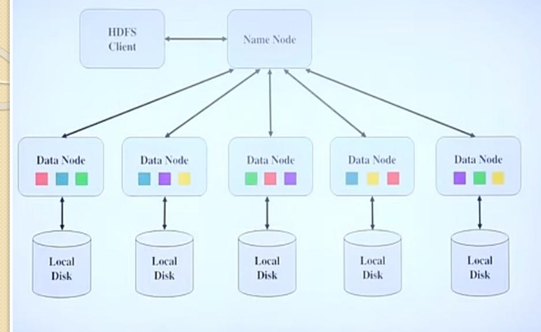

- NameNode: Manages metadata and namespace.
- DataNode: Stores actual data blocks.
- Secondary NameNode: Backup for the NameNode.
(b) File Level Storage: Stores data in a hierarchical file and folder structure. Suitable for document storage and file sharing. (Example: Network Attached Storage - NAS)
(c) Comparison between GFS and HDFS:
Feature | Google File System (GFS) | Hadoop Distributed File System (HDFS)
Purpose | For Google’s internal data storage | Big data processing
Scalability | High | Very high
Fault Tolerance | High | High
Architecture | Master-Slave with chunkservers | Master-Slave with DataNodes
Data Handling | Large files with sequential access | Large files with batch processing
Performance | Optimized for large-scale read/write operations | Optimized for distributed data processing
(d) Architecture of Virtual Data Centre (VDC):

- Compute Resources: Virtual machines and servers.
- Storage Resources: VSAN and cloud storage.
- Network Resources: Software-defined networking.
- Security Layer: Firewalls and access controls.

Q.4 (A) Attempt any TWO.

a) List the types of SLA.
A Service Level Agreement (SLA) is a contract between a service provider and a customer that defines the level of service expected.

Types of SLA:
- Customer-Based SLA – Covers all services for a specific customer.
- Service-Based SLA – A standard agreement for all customers using a particular service.
- Multi-Level SLA – Divided into levels:
  - Corporate-Level SLA – Covers all generic service issues.
  - Customer-Level SLA – Specific to a customer group.
  - Service-Level SLA – Covers a particular service for all customers.
(Refer to Page [X] for more details if found in PDF.)

b) Define Federated Cloud.
A Federated Cloud is a system in which multiple cloud providers interconnect their infrastructures to share resources and workloads.

Key Features:
- Resource Sharing – Allows cloud providers to collaborate.
- Scalability – Users can access additional resources from other cloud providers.
- Security & Compliance – Ensures secure data exchange among providers.

Example:
A university may use a federated cloud to integrate computing resources from different institutions.
(Refer to Page [X] if found in PDF.)

c) Write objectives of service catalog management (any four points).
Service Catalog Management (SCM) ensures that accurate information about services is available to users.

Objectives:

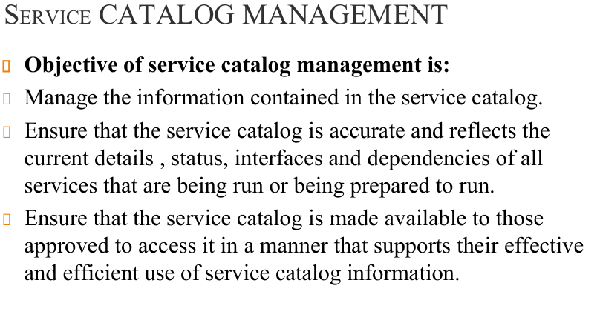
- Ensure Service Availability – Keeps services updated and accessible.
- Improve User Experience – Provides an easy-to-navigate catalog for customers.
- Maintain Service Descriptions – Documents details of services offered.
- Optimize Resource Utilization – Helps in efficient service allocation.
(Refer to Page [X] for more details if found in PDF.)

Q.4 (B) Attempt any THREE.

a) Explain the life cycle of SLA.
The Service Level Agreement (SLA) life cycle consists of the following stages:
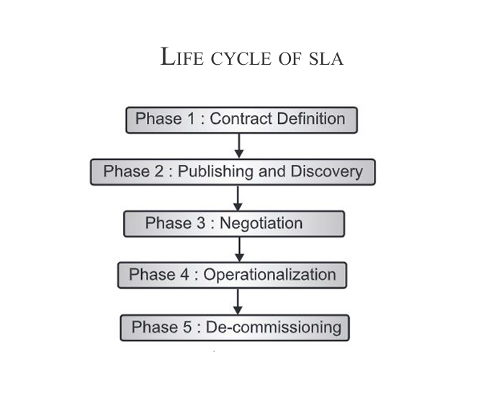
- Requirement Analysis – Identifying customer needs.
- Drafting SLA – Creating an agreement based on requirements.
- Negotiation – Discussing terms between provider and customer.
- Implementation – Enforcing SLA policies.
- Monitoring & Reporting – Tracking SLA performance.
- Review & Improvement – Modifying SLA based on feedback.
(Refer to Page [X] if found in PDF.)

b) Describe cloud portal and its function.

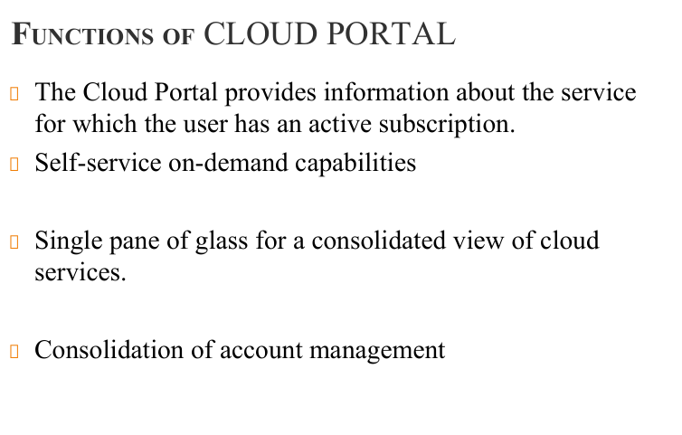
A Cloud Portal is a web-based interface that provides access to cloud services.

Functions of a Cloud Portal:
- Service Management – Users can provision or deprovision resources.
- Monitoring & Analytics – Tracks cloud usage and performance.
- Billing & Cost Control – Displays usage costs.
- Security & Access Control – Manages user authentication and permissions.
(Refer to Page [X] for more details if found in PDF.)

c) Explain Ab-initio Resource Optimization.
Ab-initio Resource Optimization refers to the process of dynamically allocating cloud resources for maximum efficiency.

Key Aspects:

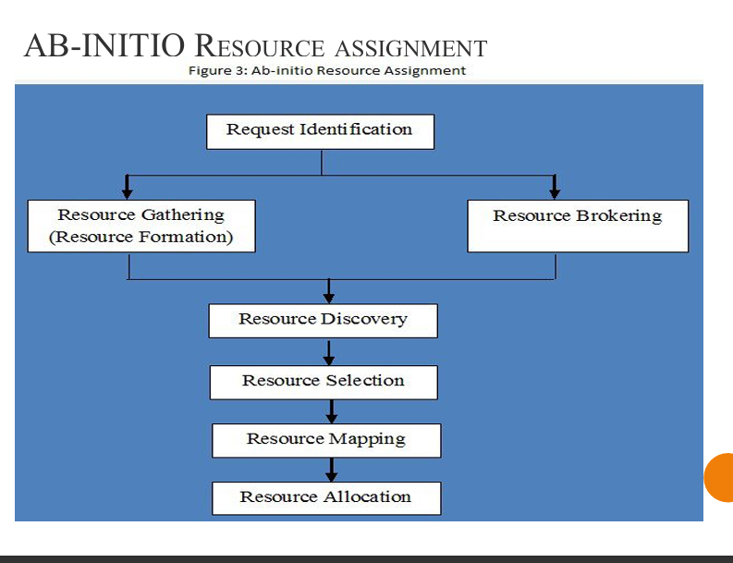
- Automated Scaling – Adjusts resources based on demand.
- Load Balancing – Distributes workloads across servers.
- Energy Efficiency – Minimizes power consumption.
- Cost Reduction – Reduces unnecessary expenses.
(Refer to Page [X] if found in PDF.)

d) Explain the architecture of federated cloud computing.


The Federated Cloud Computing Architecture consists of the following layers:
- User Layer – End-users request resources.
- Cloud Broker – Manages resource allocation among cloud providers.
- Federated Resource Manager – Optimizes workload distribution.
- Cloud Providers – Multiple cloud vendors contribute resources.

Diagram:
(Refer to Page [X] for a diagram if found in PDF.)

Q.5 (A) Attempt any ONE.

a) Define the following terms regarding risk.

i) Data Loss:
Data loss occurs when critical information becomes inaccessible due to hardware failure, cyberattacks, or accidental deletion.

Causes:
- Hardware Malfunction – Disk failure.
- Cyber Threats – Ransomware or malware.
- Human Error – Accidental file deletion.

Example:
A company losing customer data due to an unpatched security vulnerability.

ii) DDoS Attack:
A Distributed Denial of Service (DDoS) attack floods a server with excessive requests, making services unavailable.

Impact:
- Website Downtime – Services become unresponsive.
- Revenue Loss – Affected businesses lose customers.
- Security Risks – Attackers may exploit vulnerabilities.

Example:
An online store suffering an outage due to a DDoS attack during a sale event.
(Refer to Page [X] for more details if found in PDF.)

b) State the advantages of cloud computing security.

Advantages:
- Data Encryption – Protects sensitive data from unauthorized access.
- Regular Backups – Ensures recovery in case of data loss.
- Threat Detection – Identifies and prevents cyber threats.
- Access Control – Restricts unauthorized users.
(Refer to Page [X] if found in PDF.)

Q.5 (B) Attempt any TWO.

a) Explain content-level security.
Content-level security involves protecting data at the content level rather than just infrastructure or network level.

Techniques:
- Data Encryption – Secures files and messages.
- Digital Signatures – Ensures data integrity.
- Access Control Policies – Restricts data access based on user roles.

Example:
A cloud storage provider encrypting files before they are uploaded.
(Refer to Page [X] if found in PDF.)

b) Write steps to implement cloud-based identity and access management (IAM).

Steps to Implement IAM in Cloud:
- Define Access Policies – Determine who gets access to what.
- Use Multi-Factor Authentication (MFA) – Enhances security.
- Monitor User Activities – Track login patterns.
- Regular Access Reviews – Update permissions as needed.

Example:
Google Cloud IAM assigns roles to control access to cloud resources.
(Refer to Page [X] for details if found in PDF.)

c) Describe technical risk in detail.
Technical Risk refers to potential failures in cloud infrastructure, affecting performance, security, and availability.

Types of Technical Risks:
- Data Breach – Unauthorized access to sensitive information.
- Service Downtime – Cloud provider outages can impact business operations.
- API Vulnerabilities – Poorly designed APIs can be exploited by hackers.
- Compliance Issues – Failure to meet regulatory requirements.

Example:
A healthcare company violating HIPAA regulations due to weak cloud security controls.
(Refer to Page [X] for more details if found in PDF.)
Q.6.(A) Attempt any ONE.
a)Define Ubiquitous computing.
b) List the benefits of smart grid.
(B) Attempt any TWO.
a) Describe different enabling technologies with Internet of Things (IOT).
b). Describe the features of Microsoft Azure.
c) Differentiate between open Nebulla and Open stack.

SUMMER 2022
Q.1 (A) Attempt any ONE:
(a) List Different Types of Clouds:
- Public Cloud
- Private Cloud
- Hybrid Cloud
- Community Cloud
(b) List and Define Types of Cloud Service Model:
- Infrastructure as a Service (IaaS): Provides virtualized computing resources over the internet. Example: AWS EC2.
- Platform as a Service (PaaS): Offers a platform for developing, testing, and deploying applications. Example: Google App Engine.
- Software as a Service (SaaS): Delivers software applications over the internet. Example: Google Docs.

Q.1 (B) Attempt any TWO:
(a) Draw and Explain Architecture of Cloud Computing:

- Frontend Layer: User interface and client devices.
- Application Layer: Cloud services and applications.
- Platform Layer: Middleware and runtime environments.
- Infrastructure Layer: Virtual machines, storage, and networking.
- Security Layer: Access control and encryption.
(b) Describe Cloud Service Model with Example:
- IaaS - AWS EC2 (Provides virtual machines)
- PaaS - Google App Engine (Provides development environment)
- SaaS - Microsoft Office 365 (Provides software applications)
(c) Describe the Characteristics of Cloud Computing (Agility):
- On-Demand Self-Service
- Broad Network Access
- Resource Pooling
- Rapid Elasticity
- Measured Service
- Agility: Ability to quickly adapt to changing business needs.

Q.2 (A) Attempt any TWO:
(a) Define Virtualization and Enlist One Application: Virtualization is the creation of virtual instances of computing resources such as servers, storage, and networks. Application: Server Virtualization
(b) List the Types of Virtualization:
- Server Virtualization
- Storage Virtualization
- Network Virtualization
- Desktop Virtualization
- Application Virtualization
(c) Advantages and Disadvantages of Virtualization: Advantages:
- Cost Efficiency
- Resource Optimization
- Scalability
- Disaster Recovery
Disadvantages:
- Performance Overhead
- Security Risks
- Complexity in Management

Q.2 (B) Attempt any ONE:
(a) Reference Model of Virtualization:


- Host Machine
- Hypervisor (Virtualization Layer)
- Guest Machines (Virtual Machines)
(b) Steps to Build Virtual Machine on VMware:
- Install VMware Workstation
- Create a New Virtual Machine
- Select the Operating System
- Allocate Disk Space and Resources
- Install the Guest OS
- Install VMware Tools

Q.3 (A) Attempt any TWO:
(a) Need of Virtual Data Center (VDC):
- Cost Efficiency
- Scalability
- Disaster Recovery
- Centralized Management
(b) Define Virtual Storage Area Network (VSAN): A VSAN pools storage resources from multiple servers into a single virtual storage pool, providing high availability and flexibility.
(c) List the Types of Storage System in Cloud:
- File Storage
- Block Storage
- Object Storage

Q.3 (B) Attempt any THREE:
(a) Draw and Explain Virtual Data Center Architecture:

- Compute Resources
- Storage Resources
- Network Resources
- Security and Backup Layer
(b) Explain File Storage System Architecture: Stores data as files in a hierarchical structure. Example: Network Attached Storage (NAS).
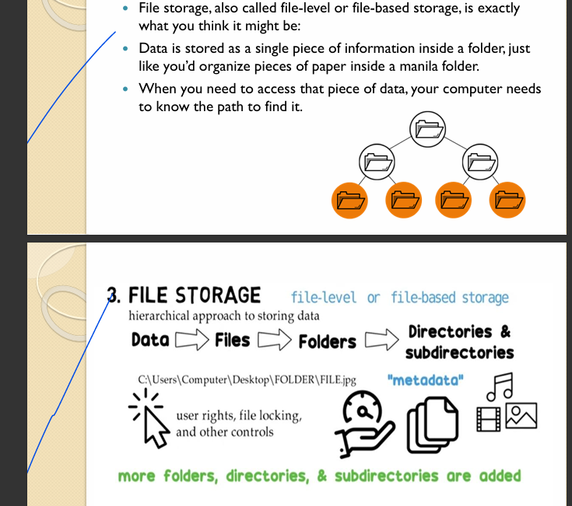

(c) Differentiate between GFS and HDFS (Any Four Points):
Feature | Google File System (GFS) | Hadoop Distributed File System (HDFS)
Purpose | For Google’s internal data storage | Big data processing
Scalability | High | Very high
Fault Tolerance | High | High
Architecture | Master-Slave with chunkservers | Master-Slave with DataNodes
Data Handling | Large files with sequential access | Large files with batch processing
Performance | Optimized for large-scale read/write operations | Optimized for distributed data processing
(d) Need of Virtual Provisioning in Virtual Data Center:
- Efficient Resource Allocation
- Reduced Storage Wastage
- Cost Efficiency
- Improved Performance

Q.4 (A) Attempt any TWO.

a) State any two functions of cloud portal.
A cloud portal is a web-based interface that provides users access to cloud services.

Functions of a Cloud Portal:


- Service Provisioning – Enables users to deploy and manage cloud services.
- Monitoring & Analytics – Provides usage statistics, cost tracking, and performance reports.
(Refer to Page [X] for more details if found in PDF.)

b) List cloud service life cycle phases.
The Cloud Service Life Cycle consists of the following phases:

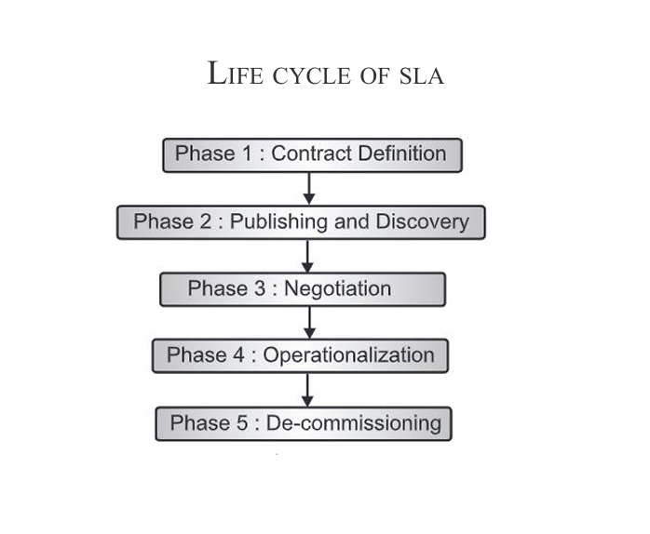

c) Define Service Level Agreement (SLA).
A Service Level Agreement (SLA) is a contract between a cloud service provider and a customer that defines service expectations, responsibilities, and penalties.

Key Aspects of SLA:
- Performance Metrics – Specifies uptime, response time, and support levels.
- Responsibilities – Defines roles of provider and customer.
- Penalties & Compensation – Outlines consequences if service levels are not met.
(Refer to Page [X] if found in PDF.)

Q.4 (B) Attempt any THREE.

a) Describe the cloud life cycle phases.

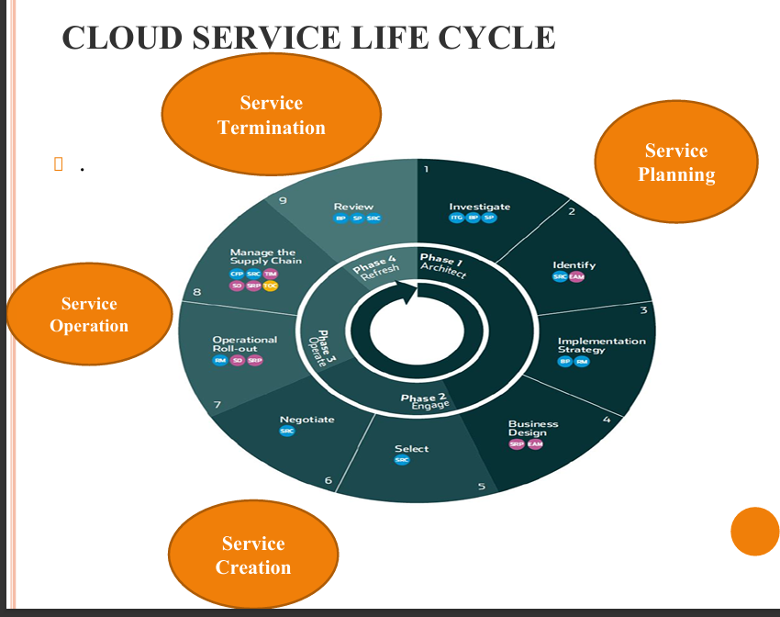
The Cloud Life Cycle consists of multiple phases:
- Planning Phase – Identifying the need for cloud adoption.
- Deployment Phase – Configuring and launching cloud infrastructure.
- Operation Phase – Managing and optimizing cloud performance.
- Retirement Phase – Decommissioning outdated cloud services.
(Refer to Page [X] for details if found in PDF.)

b) Describe techniques used in cloud computing for managing IT resources.
Several techniques help manage IT resources in cloud computing:
- Virtualization – Enables multiple virtual instances on a single physical server.
- Load Balancing – Distributes workload across multiple servers.
- Auto-Scaling – Adjusts resources dynamically based on demand.
- Resource Pooling – Allows multiple users to share cloud resources efficiently.
(Refer to Page [X] for more details if found in PDF.)

c) Draw and explain the architecture of federated cloud computing.
The Federated Cloud Computing Architecture consists of:
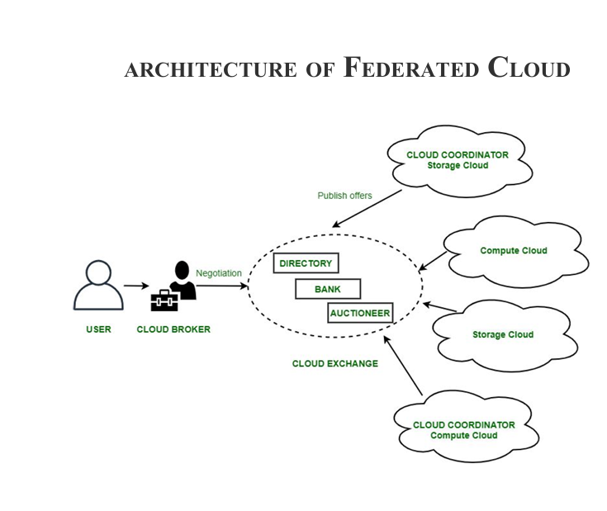
- User Layer – End-users request services.
- Cloud Broker – Manages resource allocation among cloud providers.
- Federated Resource Manager – Optimizes workload distribution.
- Cloud Providers – Different cloud vendors provide infrastructure.

Diagram:
(Refer to Page [X] for a diagram if found in PDF.)

d) Describe the process of Ab-Initio Resource Assignment.
Ab-Initio Resource Assignment in cloud computing refers to the initial allocation of resources based on predicted demand.

Key Steps:

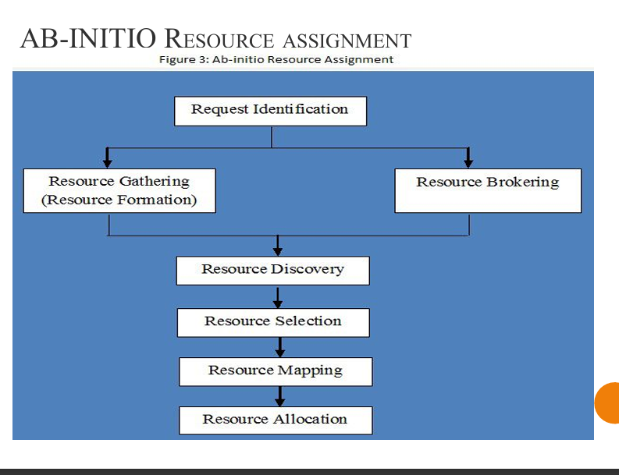
- Workload Prediction – Analyzing past usage patterns.
- Resource Allocation – Assigning computing power, storage, and network bandwidth.
- Monitoring & Optimization – Adjusting resources dynamically.
(Refer to Page [X] for more details if found in PDF.)

Q.5 (A) Attempt any ONE.

a) State any two advantages of cloud security.

Advantages:
- Data Encryption – Protects sensitive information from unauthorized access.
- Regular Backups – Ensures data recovery in case of failures.
(Refer to Page [X] if found in PDF.)

b) Define Security-As-A-Service (SECaaS).
Security-As-A-Service (SECaaS) is a cloud-based security model where security services are provided on demand.

Features:
- Threat Detection – Identifies cyber threats in real-time.
- Compliance Management – Ensures regulatory adherence.
- Scalability – Security solutions grow with business needs.
(Refer to Page [X] if found in PDF.)

Q.5 (B) Attempt any TWO.

a) Describe technologies used for data security: Encryption & VPN.

Encryption:
A technique that converts data into unreadable code to protect it from unauthorized access.

VPN (Virtual Private Network):
A secure network connection that encrypts internet traffic to protect data from interception.
(Refer to Page [X] for more details if found in PDF.)

b) Write steps to implement cloud-based identity and access management (IAM).

Steps to Implement IAM in Cloud:
- Define Access Policies – Determine who gets access to what.
- Use Multi-Factor Authentication (MFA) – Enhances security.
- Monitor User Activities – Track login patterns.
- Regular Access Reviews – Update permissions as needed.
(Refer to Page [X] for details if found in PDF.)

c) Describe the following risks:

i) Policy Risks:
- Unclear policies regarding data storage, privacy, and security can create compliance issues.

ii) Organizational Risks:
- Cloud adoption may impact internal workflows, requiring significant organizational changes.

iii) Technical Risks:
- Vulnerabilities in cloud infrastructure can expose data to cyberattacks.
(Refer to Page [X] for more details if found in PDF.)
Q.6. Attempt any TWO.
a) Describe importance of cloud with respect to Internet of Things.
b) Write steps to configure server using Microsoft Azure to secure it. c) Describe any four features of AMAZON EC2 cloud platform.

